Computer Vision HW1

系級：資工碩一 學號：R07922162 姓名：胡嘉祐

**part 1 : use python**

1.upside-dwon 2.right-side-left

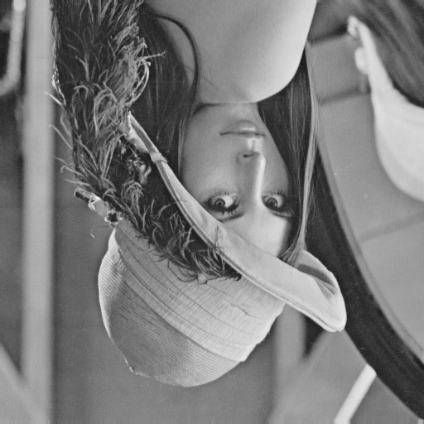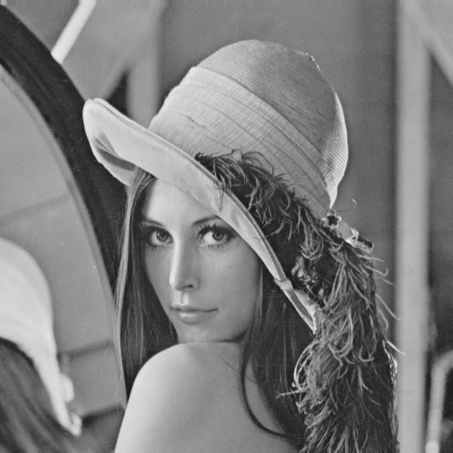

3.diagnolly mirrored

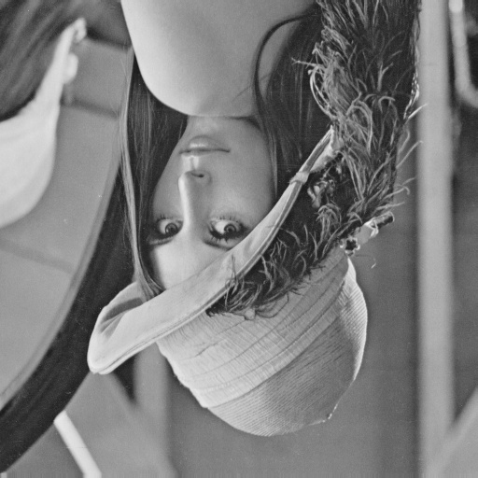

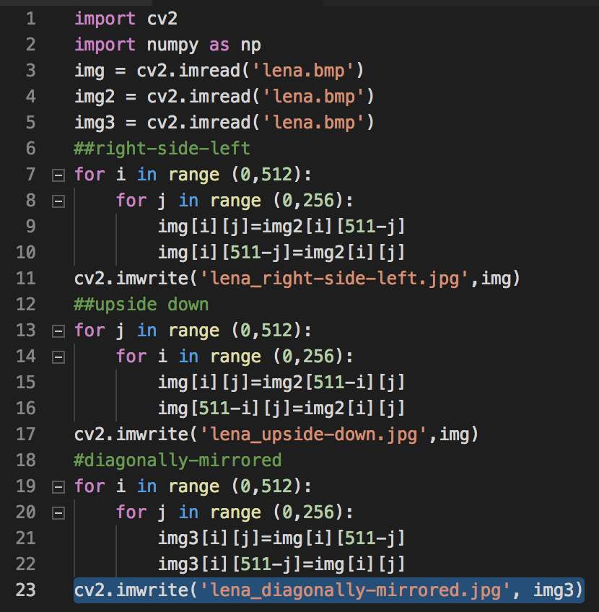

**source code**

import cv2

import numpy as np

img = cv2.imread('lena.bmp')

img2 = cv2.imread('lena.bmp')

img3 = cv2.imread('lena.bmp')

##upside down

for i in range (0,512):

for j in range (0,256):

img[i][j]=img2[i][511-j]

img[i][511-j]=img2[i][j]

cv2.imwrite('lena_upside-down.jpg',img)

##right-side-left

for j in range (0,512):

for i in range (0,256):

img[i][j]=img2[511-i][j]

img[511-i][j]=img2[i][j]

cv2.imwrite('lena_right-side-left.jpg',img)

#diagonally-mirrored

for i in range (0,512):

for j in range (0,256):

img3[i][j]=img[i][511-j]

img3[i][511-j]=img[i][j]

cv2.imwrite('lena_diagonally-mirrored.jpg', img3)

**part.2 use photoshop**

1. rotate 45 degrees clockwise 2.shrink in half

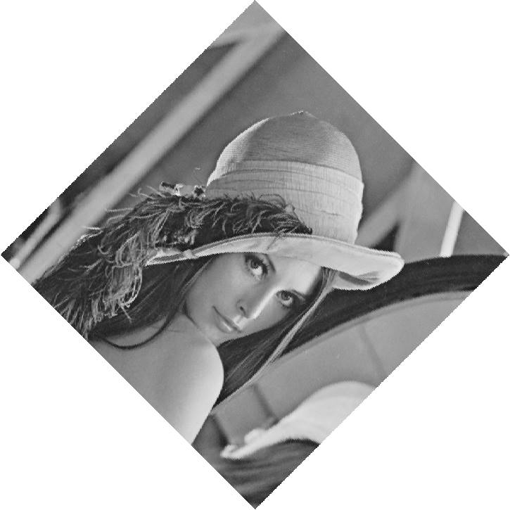 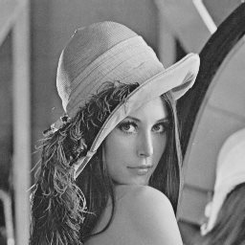

1. binarize at 128

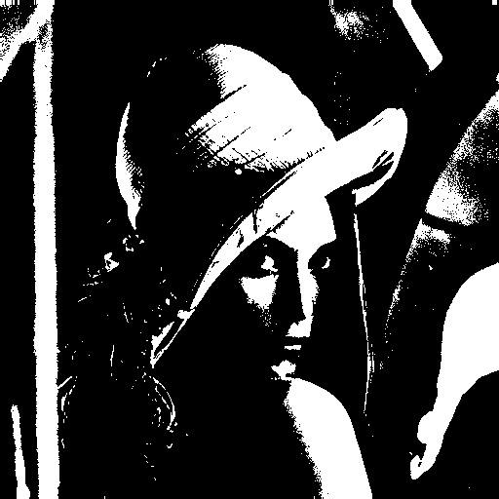

method:

1.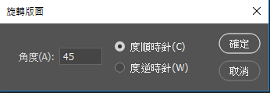

2.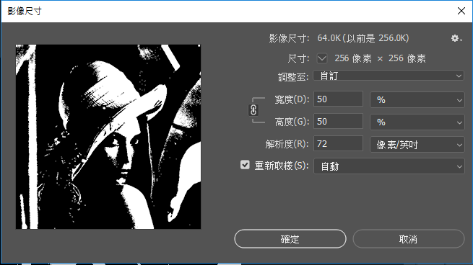

3.